
AUCKLAND ROWING CLUB

MEMBER INDUCTION AND ORIENTATION

Name :

Has achieved basic competencies in rowing through the completion of the ARC Orientation.

Signature of ARC Executive / Coach

Date:

Version 1.2 August 2010

ROWING BASICS
Instructors use this checklist to ensure that the rowers have gained all the competencies required.
Once all boxes have been completed then the participant can be given the ARC Orientation Certificate.

Initial as
completed

- Can swim 100 metres.
- Capsize Drill
- Name parts of the boat and oars
- Carrying the boat/oars
- Getting in and out of the boat
- General boat manoeuvres to include
Launching the boat from the ramp, beach and a pontoon
Turn the boat 360° in one direction. and then the other
Row the boat backwards and forwards in a straight line
Emergency stop of the boat
- General rowing to include
Rowing continuously with full slide
Rowing with variable length slide
Rowing with good ratio of drive and :recovery
- Basic drills to be learnt include
Square blades and delayed feather
Slide check and Shoe checks
Catch exercise and single strokes

ROWING SAFETY – BASIC RULES
- All rowers must be able to swim l00m in full rowing clothes
- Study the map in your club, and in this booklet, that shows local traffic flow.
The Risk management Plan identifies DANGER SPOTS, SAFE
LANDING AREAS and HOURS OF OPERATION etc…
Make sure you have read and understand these items. If you do not understand any of these points, ASK!

- Right of way- generally, international rules say:
  - To keep the shore close to your left….
[Rowers and scullers left, coxswains right]
So that traffic moves in a counter clockwise rotation.
Keep RED markers on rowers’ left and GREEN markers on rowers’ right.
  - Rowing boats always give way to sailing boats and faster rowing boats.
  - Rowing boats should be careful with large powered vessels that cannot easily manoeuvre (usually motor boats, ferries, fishing boats) should give way to rowing boats.
  - Coxed boats should give way to coxless boats. If a collision is imminent, CALL OUT!!

- Lights - before dawn or after dusk rowing boats MUST carry a continuous white light mounted 1 metre above the bow canvas, and visible from 360 degrees.

- Emergency signals - two arms for emergency, one arm for nonemergency, lights over the head and/or whistle can be used.

- Wear appropriate clothing - clothing should not restrict movement nor be so baggy to let the fingers get caught around the finish

- Check your equipment is safe before going on the water.

- Courtesy - always be courteous to other water users; bad language or abuse is unacceptable and does not do anything positive for safety or the sport.
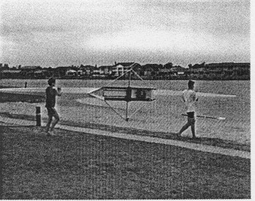

SAFETY POSITION
- This position is secure for the single sculler where the boat is very stable and cannot tip over -use for beginners who feel insecure or when the boat is unstable (from a boat wash)
- The rower sits with legs straight
- Both handles are held firmly together with the oars perpendicular to the boat and the blades flat on the water.

BOAT CAPSIZE DRILL

- All rowers should complete a capsize drill before starting to row; this activity can be done in a swimming pool
- Once the rower is in the water the boat can be turned over by standing on the nearside rigger -watch out for the oar as the boat turns
- Ensure that you have the two handles held together before getting back into the boat
- Check with your club policy first as some clubs prefer the boat to be swum to shore rather than risk damage to the boat if it is only a matter of metres.
TO GET BACK IN THE BOAT….

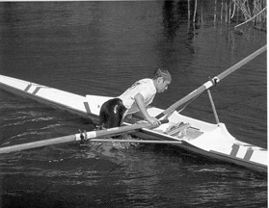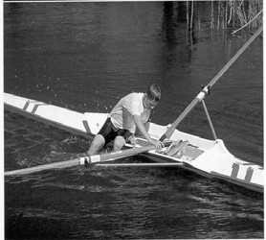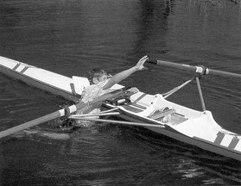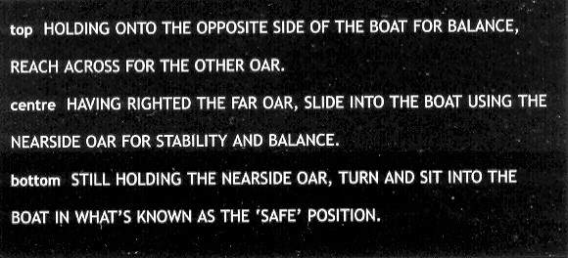

SURVIVING ON THE TAMAKI

- Avoid going out alone, especially outside peak times of early morning/ late afternoon.
Row with a friend or have a coach accompany you. Otherwise, tag along with another group.
Be aware of wind against tide conditions….

- Ensure you complete the Rowing Log, located by the notice board in the main entrance.
Record:
Crew, Boat name, date and time of departure and direction headed.
- If you capsize, use the BUDDY SYSTEM in crew boats where athletes pair up (Bow with 2 seat, 3 seat with 4 etc) to keep track of all crew members - don't forget the coxswain.
- If you capsize, get back in the boat quickly;
If that is not possible
  - STAY WITH THE BOAT preferably lying over the boat with as much of your body out of the water as possible
  - Roll the boat to increase flotation; use bits of the boat/oars if boat has broken
  - Try to attract attention e.g. whistle, waving arms
  - DO NOT TRY TO SWIM TO SHORE, even if you are a good swimmer
  - Do not move around to try and keep warm; in cold water you will lose warmth and energy very quickly.
- If you are with other scullers or rowers and capsize, decide on the best of the following options
(Choice will depend on circumstances)
- Let them help you get back in the boat
- Let them go for help, either from the nearest club or from a passing motorboat
Bowball
Mandatory
on all boats

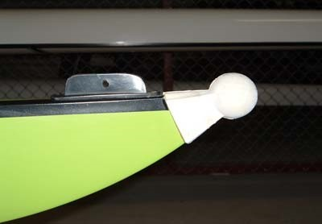
BASIC ROWING TERMINOLOGY

Number holder
Shell or Hull

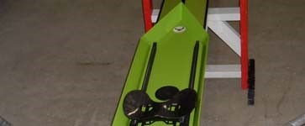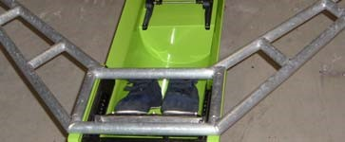

Slides
Feet
/
Shoes
/

Foot stretcher
Seat
Sculling
Wing Rigger
Dump / Trestle

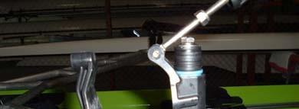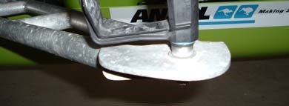

Rigger
Oarlock &
Gate
Oarlock Pin
Height adjusting washers

 | 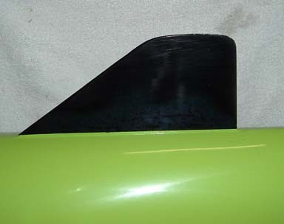
  Fin or Skeg

 | 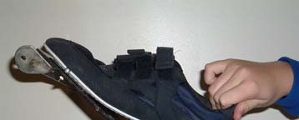  50  mm maximum
  Feet
travel

Unlimited Heal Travel – WRONG!
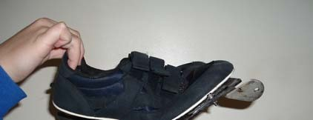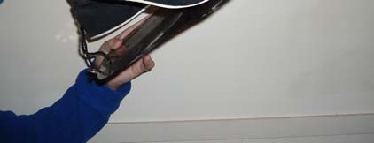

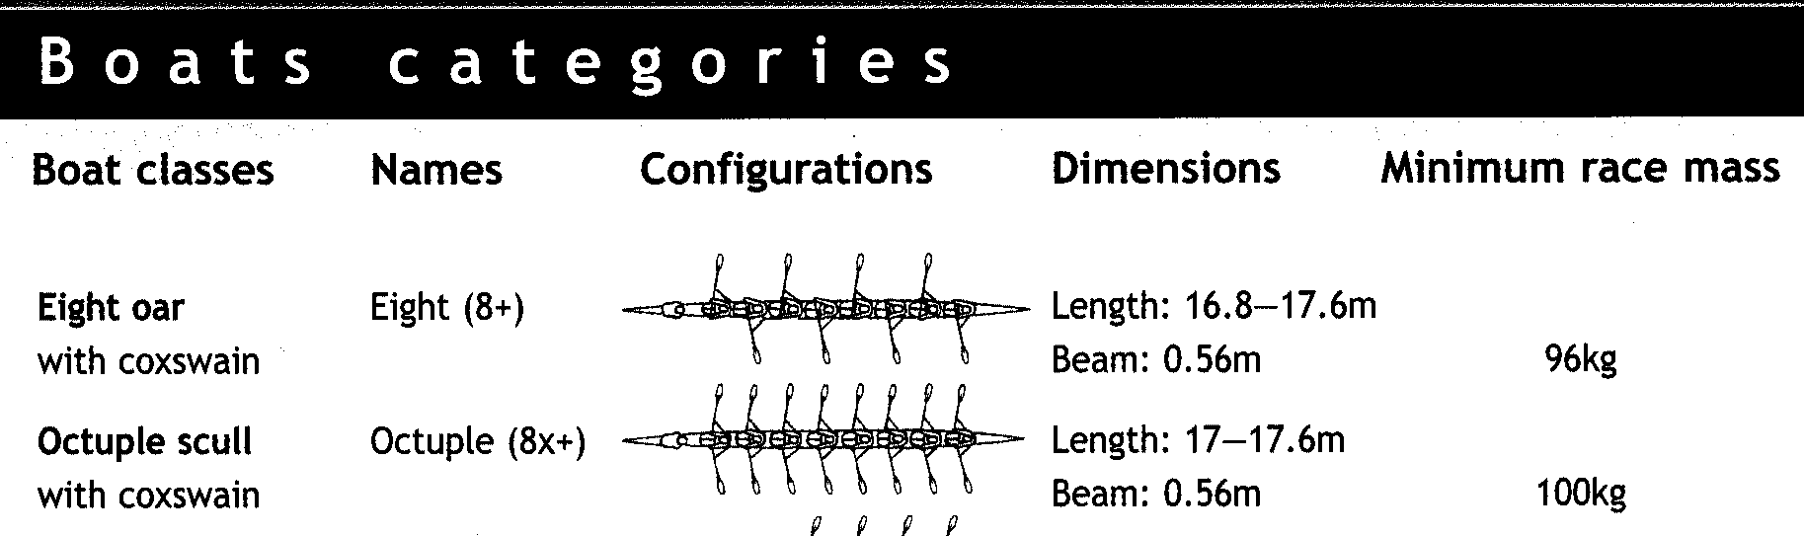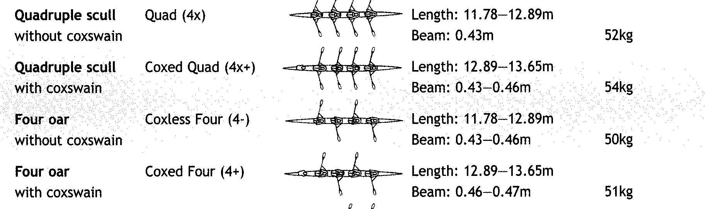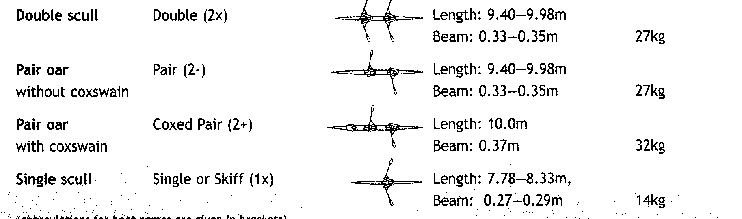

OARS, SCULLS AND RIGGING

Sculling
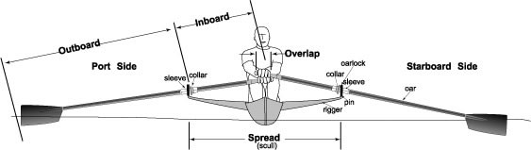

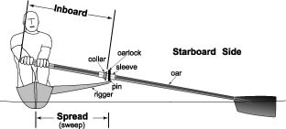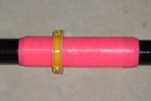
Sweep Rowing

Shaft
Collar
Sleeve

EQUIPMENT CHECKS AND ADJUSTMENTS
The following should always be checked before going on the water.
Ensure that all parts are there, tight and not damaged:
- Bow ball fitted correctly
- Heel safety straps tied correctly on shoes in the foot stretcher
- No damage to the hull of the boat.
- Sealed bow and stern compartments.
- Oarlock gates close and lock properly.
- All moving parts tight and in good working order
I.e. seats, riggers

The basic adjustment that all rowers need to make is the FOOT STRETCHER ADJUSTMENT. This can be done on the land before you get into the boat or on the water -just make sure that you have your oar handles in your lap when you loosen the thumb screws on the foot stretcher.
Adjusting the foot stretcher toward the bow or the stern changes the arc of the stroke and how comfortably or efficiently you will be able to move the boat:
- Sitting too far to the stern means the oar handles will not come back enough to move the boat effectively,
- Sitting too far to the bow means the oar handles will come back too far and again, not be able to move the boat effectively SCULLERS- hands should be about 15cm apart at the Finish position

ROWERS -outside hand should be at the edge of the body at the Finish position

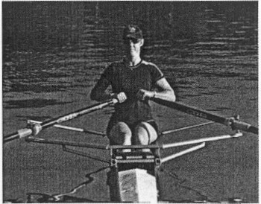

ROWING RULES

ROWING SAFETY SKILLS

Check your equipment is safe
- Bow ball fitted
- Heel safety straps on foot stretcher
- Sealed bow and stern compartments
- Oarlock gates close and lock properly
- All moving parts tight and in good working order

DRESS APPROPRIATELY In winter

- Wear close-fitting stretch fabric rowing shorts/tights(leggings) and bright tops
- Wear many layers of light but close-fitting garments rather than two thick layers -remove layers as you warm up (put into a plastic bag to keep dry!)
- In cold conditions wear thermal underwear as a base layer, woollen or thermal socks
- Wear head gear such as a beanie, balaclava or hat, plus headband that covers your ears
- You may need gloves or rowing mittens on colder mornings

In summer
- Wear a hat and sunglasses
- Wear long sleeved tops to avoid over-exposure to the sun
- Always apply sunscreen

RESCUE BOAT PROCEDURES
- Safety boats need at least 2 people to counter-balance weight as rower being rescued is lifted into the safety boat
- Ensure that safety boat capacity is not exceeded -make several trips if necessary
- Practice the rescue drill approach, rescue into the wind / current.
- Rescue those in greatest stress first
GET DRY AND WARM AS SOON AS POSSIBLE.

TREATMENT OF HYPOTHERMIA
- Commence 'artificial respiration' if necessary
- Get the hypothermic victim dry and warm but not too warm too quickly.
- Use thermal blankets, a warm room, or someone else's body heat in a blanket to help the warming process.
- Give warm fluids e.g. Milo, tea, coffee, soup.

HEALTH WARNING
Rowers over 40 years of age should consider having a medical check up before rowing.

o All rowers should have a medical screening before commencing a
serious training programme o Please inform your club, coach and boat race officials if you have a
medical condition that may affect your safety.
E.g. asthma, epilepsy, diabetes, heart condition.

ROWING RULES TO SURVIVE

FOR COACHES
- Update your knowledge - local hazards, weather conditions, club emergency procedures, coach boat procedures, basic first aid and CPR.
- Make sure your coach boat has all its prescribed lighting and safety equipment.
- Ensure that you teach your crew/s the safety procedures and that you check whether they can swim.
- Wear appropriate clothing for comfort
- Consider carrying a mobile phone for emergencies.
- Make sure you follow your rowers closely if foggy conditions commence.
- Err on the side of caution in risky weather conditions such as electrical storms, rough water or heavy fog; choose alternative training e.g. ergo, bike, run, weights, aerobics.
- Remember that you have a 'duty of care' to your rowers; don't make them take unnecessary risks that endanger their safety

FOR CLUBS
- Ensure that Risk Management Program is constantly evaluated and that Insurance cover is appropriate.
- Ensure that your members are aware of the club rules and rowing safety procedures - post them in full view.
- Ensure that the log book / board is completed each time a crew goes training.
- Ensure that all coaching boats are properly equipped.
- Ensure that all your club rowing boats are unsinkable i.e. canvasses at the bow and stern are sealed and seaworthy.
- Ensure adequate first aid kit and fire extinguishers are kept in the clubhouse.
- Ensure appropriate CPR information is in full view.
- Ensure that a supervising adult is always located at the clubhouse when juniors are rowing
- Know where the nearest phone is located - list emergency numbers for police, fire, and ambulance

CONSIDER THE CONDITIONS BEFORE GOING OUT
Do not row if…
- There are electrical storms about e.g. lightning/thunder
- The weather is stormy or squally
- The waves have 'white caps'
- There is thick fog
- It is extremely cold
- Consider other forms of training when rowing conditions are risky.
E.g. erg, bike, run, weights, aerobics

TRAINING ZONES

Northern Route

From Auckland Rowing Club to Half Moon Bay o Through Pakuranga Motorway Over bridge o Through (rowers) left Arch of “Old” Panmure bridge o Down past the Panmure Wharf, towards St. Kentigerns College. o Follow green and red marker poles and Buoys around Pt England to Half Moon Bay.

Southern Route

From Auckland Rowing Club to the Southern Motorway o To the top of the estuary o Ensure the channel is followed at medium or low tide. o Follow Red and Green marker poles up towards Southern
Motorway. o Follow channel up to the large marker pylons by the motorway. o Care: There are many stakes in the river around this area, stay in the channel, and away from the edge of the river.

ROWING CLUB PRECINCT

Care is required in the following areas:

1. | Parking lot and entrance drive.  The rowing club is also the entry / exit for dragon boat, canoeing, Waka and other motorised and non motorised water sports.  Other traffic in the area includes general visitors to the river and commercial vehicles using Ferry access from the public boat ramp.  Ensure all vehicles are parked on designated parking areas. The areas directly in front and behind the boat shed are no parking areas.
2. | Inside the Boatshed and Club House o Care around all plant… oars, rowing shells, motor boats and gym equipment. o Wet areas inside and outside the boat shed.  E.g. Boat washing areas, showers and bathrooms.  - With engine fuel and fuel tanks.  - All areas inside the Auckland Rowing Club are designated  NON SMOKING areas.
3. | On the Water o The boat launching ramp may be wet and slippery – particularly at medium or low tide.  - At extreme low tides the edge of the boat ramp may be exposed  or just covered.  - Ensure boats are put into the water with plenty of water under the  keels, fins and rudder.  - Other water based craft – including motorised and non motorised boats.  - Fixed and transient Obstructions o Moorings (visible and those that float just below water surface) o Moored Boats o Marker Poles, Buoys and Pylons.  - Bridges and Structures  - Debris in the river (particularly after high tide or heavy rain.) o Mud / shell banks off the channel line. (at med and low tide) o Fishing Lines (from ramp, wharves etc.) o Current – particularly around permanent structures.  - Wash – from other boats (motorised and non motorised.) o Reef - located between marker poles by Panmure Wharf.  - Boats not observing the “rules of the River”
4. | General o Wind and Tide conditions o Wind against tide makes boat control difficult. o Marine and Wildlife on the river. o Unclean condition of the Water in the case of capsize. o General Medical – cuts exposed to river water.  o Under no circumstances – swim or drink the water from the  Tamaki Estuary.

See Appendix A for a map of the ARC Rowing Precint.

ROWING CLUB SECURITY
1. | The Boatshed and Clubhouse.  Ensure that:  All doors are locked when going out to row.  All roller doors are securely shut and locked when going to row. The alarm is activated if you are the last crew / person exiting the shed.  If in doubt – arm the ALARM!!!  Note: There have been instances of theft from the clubhouse and changing rooms over the years.  Make sure you protect your items (keys / wallets / watches / phones etc…) and those of other club members when training from the ARC.  For instruction on how to use the club alarm – ask a senior club member.  They will only be too happy to show you how to arm and disarm the Alarm.
2. | The Boat Log  For each outing, make sure you complete the boat log on the whiteboard in the Club house. It is the stroke of each boat that is responsible for completing the details for the outing.  Write up:  Date and time leaving  The direction in which you intend rowing / sculling.  The name of the boat; which you are using.  Crew Names

If you require assistance with these or other risks and club related issues, please approach and discuss this with a coach or any official of the Auckland Rowing Club.
Appendix A
